

Lab Manual- Setup and Manage Docker

Compose for Multicontainer

Prepared for:

Date: 18th Nov 2018

Prepared by:
Document Name: Lab Manual Document Number DevOpsLab401
Contributor:

Table of Contents

1 OBJECTIVE ............................................................................................................3

2 PRE-REQUISISTE ..................................................................................................3

3 How Docker Compose Work .................................................................................3

4 Setup Up Docker Compose...................................................................................4

4.1 Manage Compose Conatiner ............................................................................................... 6

1 OBJECTIVE

Docker composes

▪ Tool For Defining & Running Multi-Container Docker Applications
▪ Use Yaml Files To Configure Application Services (Docker-Compose.Yml)
▪ Can Start All Services With A Single Command : Docker Compose Up
▪ Can Stop All Services With A Single Command : Docker Compose Down
▪ Can Scale Up Selected Services When Required.

In This Lab will cover the basics of configuring docker compose with web and database services

2 PRE-REQUISISTE

▪ Prior knowledge of Linux

▪ Accounts in Docker-Hub

▪ A local Computer with 4 CPU, 16 GB RAM, 200 GB disk space

3 How Docker Compose Work

▪ Docker Compose is a tool for defining and running multi-container docker applications. With Compose, we use a YAML file to configure our application’s services. And then we create and start all the services from the configuration with a single command. Here is a simple graphical illustration that shows how Docker compose works

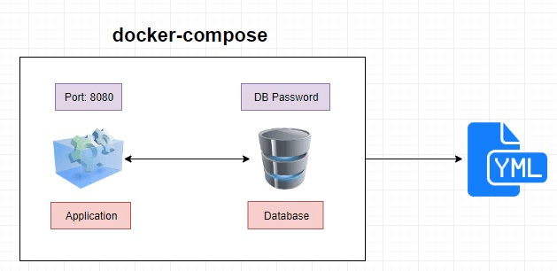

4 Setup Up Docker Compose

Steps 1: Check the docker compose version

$ docker-compose --version

Step 2: create a directory

$ mkdir dockercomposefile

Step 3: go inside the directory

$ cd docekercomposefile/

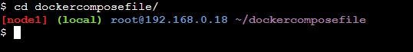

Steps 4: We are going to create simple docker compose file as an example. Here is the contents of my compose file.

vi docker-compose.yml

Steps 5: Type below steps for docker compose

Version: ‘3’

services:

web:

image: nginx

ports:

- 9090:80 database: image: redis
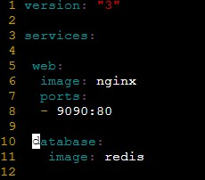

Steps 6: Type below command to check everything in docker compose is correct

docker-compose config



Steps 7: Now let’s run the docker compose ( -d is for background)

docker-compose up -d

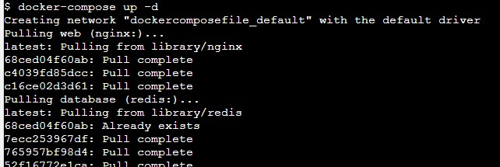

Steps 8: Now let’s check the Docker ps

docker ps

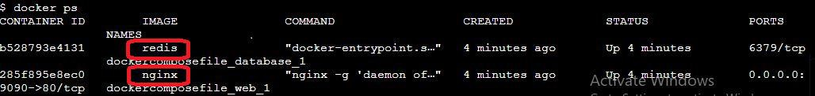

Steps 9: Now open the browser and type the IP address with port 8080



4.1 Manage Compose Conatiner

Steps 1: Shut down the container

docker-compose down



Steps 2: scale the service like database

docker-compose up -d –scale database=4

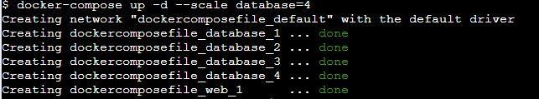

Steps 3: check the no of running container

docker ps

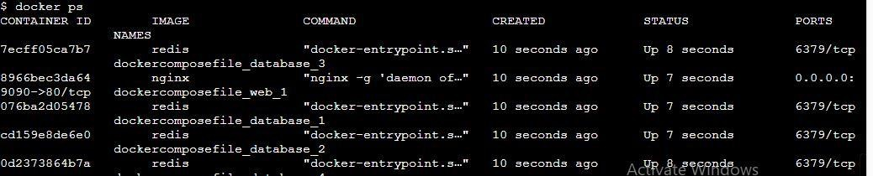

Steps 4: down the container

Docker-compose down

